***SE***

# For example, the equation {"mathml":"<mml:math style=\"font-family:stix;font-size:16px;\" xmlns:m=\"http://schemas.openxmlformats.org/officeDocument/2006/math\" xmlns:mml=\"http://www.w3.org/1998/Math/MathML\"><mml:mstyle mathsize=\"16px\"><mml:mfenced separators=\"|\"><mml:mrow><mml:mi>x</mml:mi><mml:mo>-</mml:mo><mml:mn>4</mml:mn></mml:mrow></mml:mfenced><mml:msup><mml:mi>y</mml:mi><mml:mn>4</mml:mn></mml:msup><mml:mi>d</mml:mi><mml:mi>x</mml:mi><mml:mo>-</mml:mo><mml:msup><mml:mi>x</mml:mi><mml:mn>3</mml:mn></mml:msup><mml:mfenced separators=\"|\"><mml:mrow><mml:msup><mml:mi>y</mml:mi><mml:mn>2</mml:mn></mml:msup><mml:mo>-</mml:mo><mml:mn>3</mml:mn></mml:mrow></mml:mfenced><mml:mi>d</mml:mi><mml:mi>y</mml:mi><mml:mo>=</mml:mo><mml:mn>0</mml:mn></mml:mstyle></mml:math>","origin":"MathType Legacy","version":"v3.18.2"} is a separable equation.

.

$∴$ The separable equation,



Separating variables and we get,

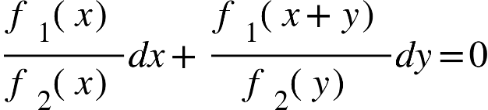

Integrating it,

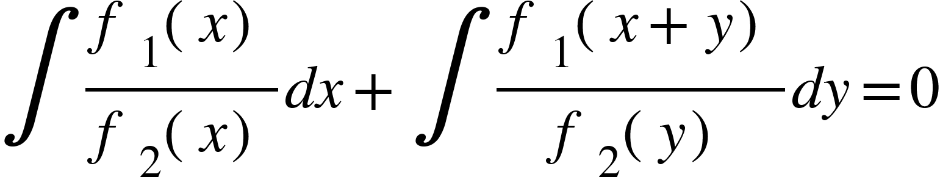



Where C is an arbitrary constant which is the required general solution.

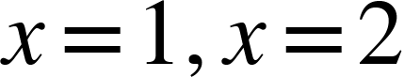 then 

Therefore,

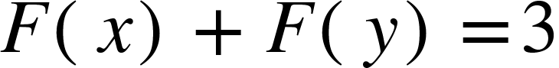

It is particular solution which we get from general equation.

**PROBLEM-1:**



**Solution:**

Given that,



This is a separable equation

Separating variables and we get,

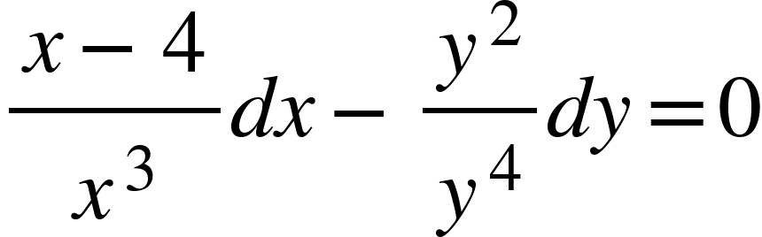

Integrating and we get,

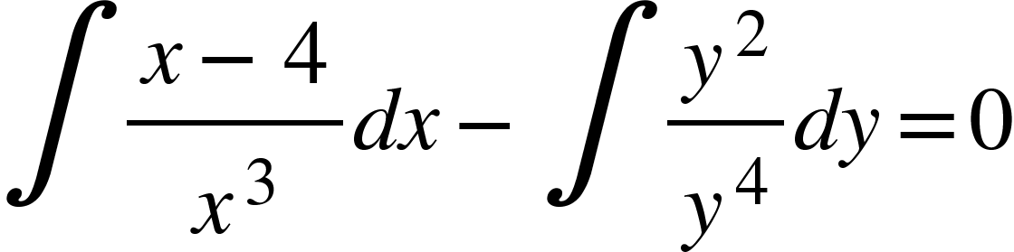

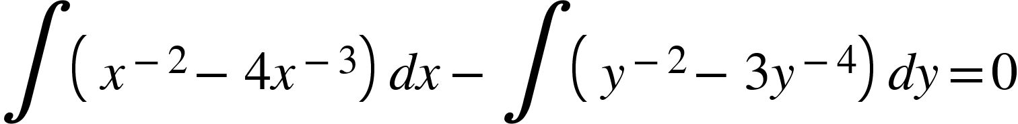

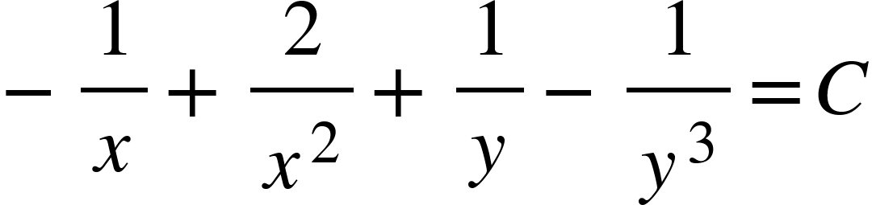

Where C is an arbitrary constant which is the required general solution.

**PROBLEM-2:**



And the initial condition {"mathml":"<math xmlns=\"http://www.w3.org/1998/Math/MathML\" style=\"font-family:stix;font-size:16px;\"/>","origin":"MathType for Microsoft Add-in"}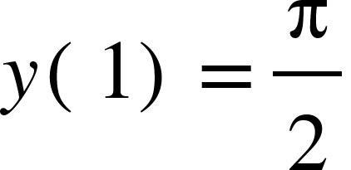

**Solution:**

Given that,



This is a separable equation

Separating variables, we get

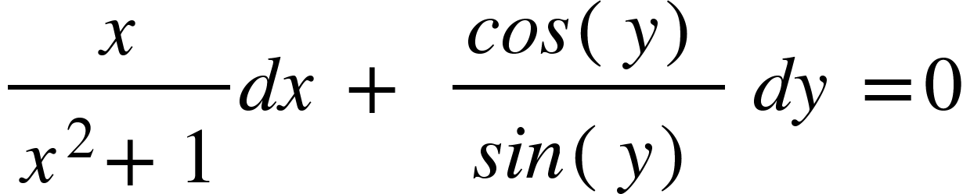

Integrating and we get,

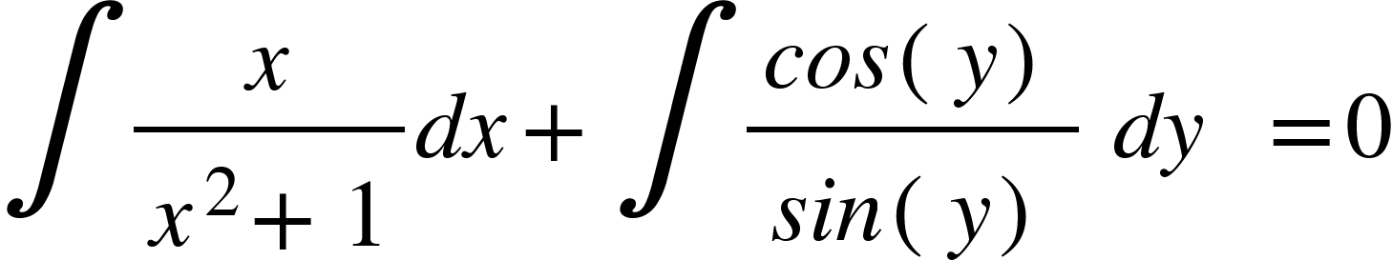

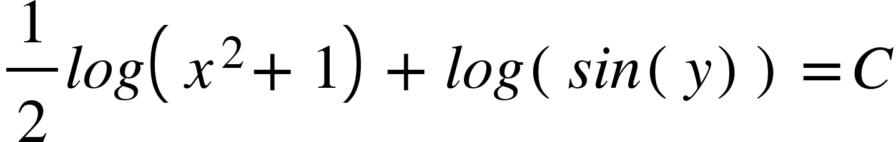

Or,

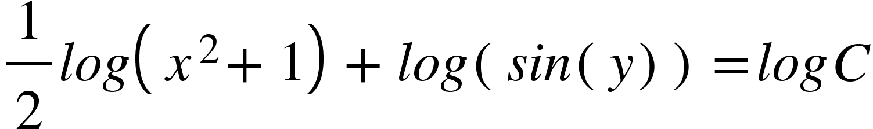

Where C is an arbitrary constant which is the required general solution.

**Exercise:**

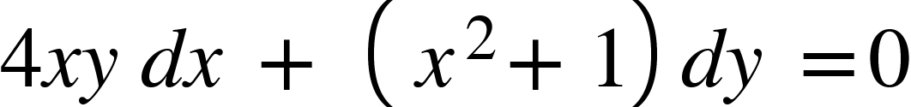

1.

Solution:



This is a seperable equation.

Seperating variable we gets,

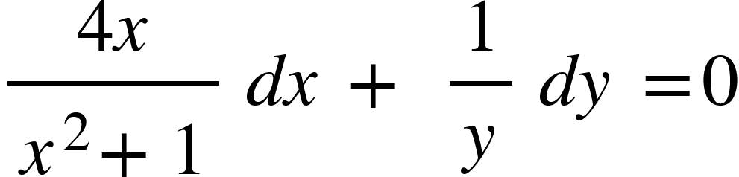

next we integrate,

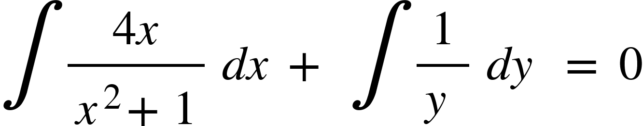



where C is the arbitrary constant which is the required general solution.



2.{"mathml":"<math xmlns=\"http://www.w3.org/1998/Math/MathML\" style=\"font-family:stix;font-size:16px;\"/>","origin":"MathType for Microsoft Add-in"}

Solution:

Since,

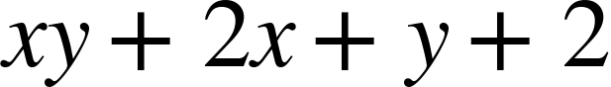



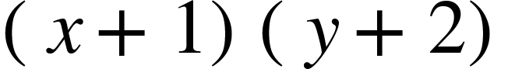



The DE can be rewritten as,

This is a separable equation

Separating variables, we get

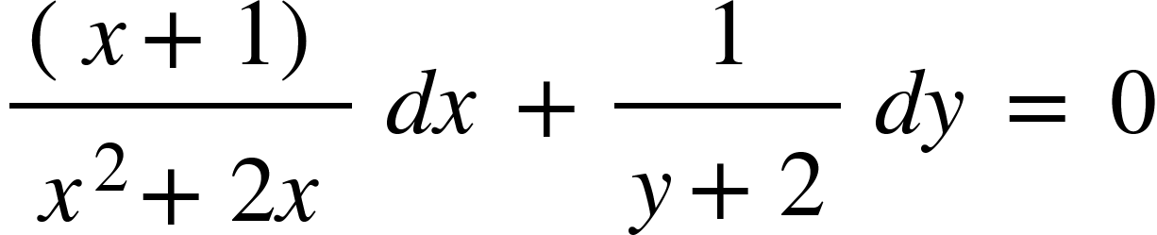

Integrating and we get,

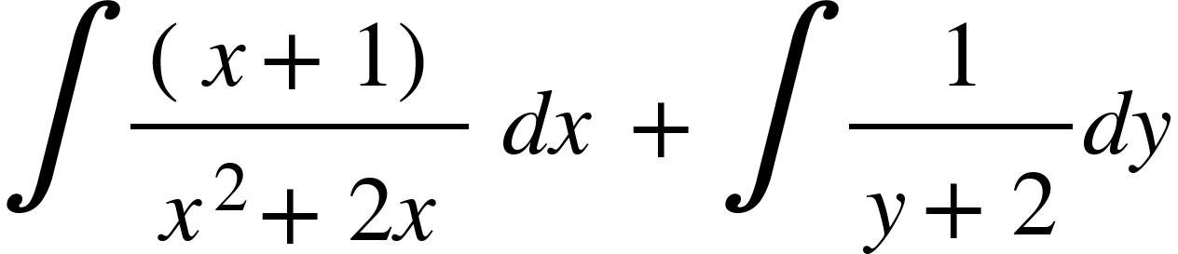

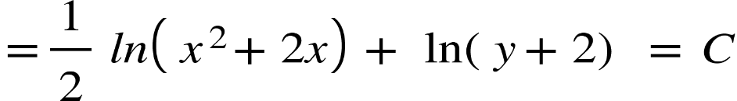

Where C is an arbitrary constant which is the required general equation.

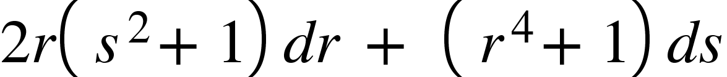

3.

**Solution:**



This is a separable equation.

Separating variable and we get,

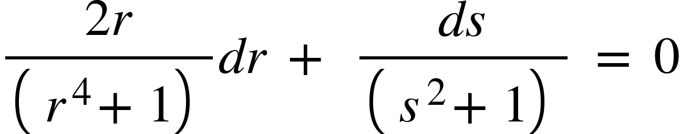

Integrating it and we get,

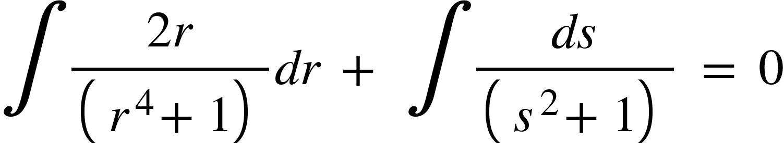

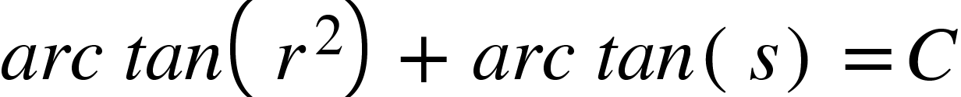

Where C is the arbitrary constant which is the required general solution.



**4.{"mathml":"<math xmlns=\"http://www.w3.org/1998/Math/MathML\" style=\"font-family:stix;font-size:16px;\"/>","origin":"MathType for Microsoft Add-in"}**

**Solution:**



This is a separable equation.

Separating variable and we get,

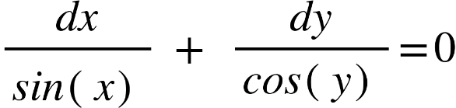

Integrating it and we get,

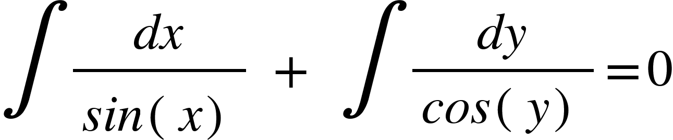



where C is the arbitrary constant which is the required general solution.



5.

**Solution:**



This is a separable equation.

Separating variable and we get,

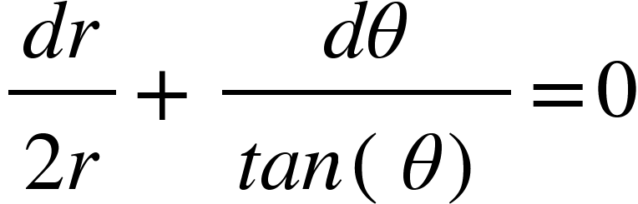

Integrating it and we get,

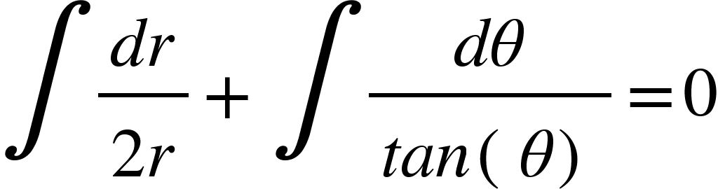

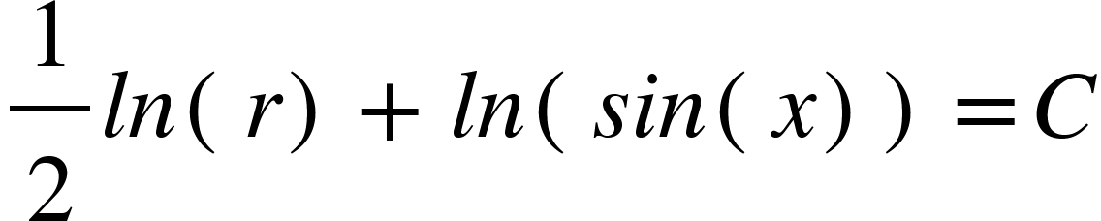

where C is the arbitrary constant which is the required general solution.

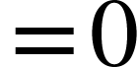

6.

**Solution:**



This is a separable equation.

Separating variable and we get,

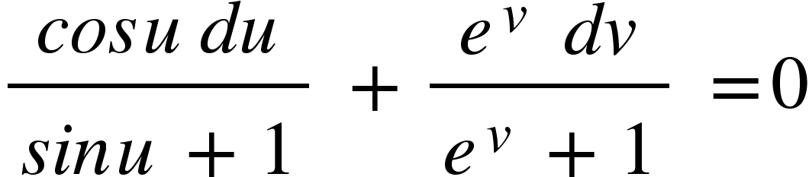

Integrating it and we get,

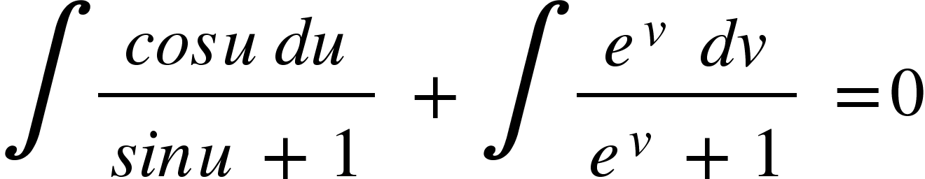

{"mathml":"<mml:math style=\"font-family:stix;font-size:16px;\" xmlns:m=\"http://schemas.openxmlformats.org/officeDocument/2006/math\" xmlns:mml=\"http://www.w3.org/1998/Math/MathML\"><mml:mstyle mathsize=\"16px\"><mml:mo>=</mml:mo><mml:mi mathvariant=\"italic\">ln</mml:mi><mml:mo>&#x2061;</mml:mo><mml:mfenced separators=\"|\"><mml:mrow><mml:mi mathvariant=\"italic\">sin</mml:mi><mml:mo>&#x2061;</mml:mo><mml:mi>u</mml:mi><mml:mo>+</mml:mo><mml:mn>1</mml:mn></mml:mrow></mml:mfenced><mml:mi>&#xA0;</mml:mi><mml:mo>+</mml:mo><mml:mi>&#xA0;</mml:mi><mml:mi mathvariant=\"italic\">ln</mml:mi><mml:mo>&#x2061;</mml:mo><mml:mfenced separators=\"|\"><mml:mrow><mml:msup><mml:mi>e</mml:mi><mml:mi>v</mml:mi></mml:msup><mml:mo>+</mml:mo><mml:mn>1</mml:mn></mml:mrow></mml:mfenced><mml:mi>&#xA0;</mml:mi><mml:mo>=</mml:mo><mml:mi>&#xA0;</mml:mi><mml:mi mathvariant=\"italic\">ln</mml:mi><mml:mo>&#x2061;</mml:mo><mml:mi>C</mml:mi></mml:mstyle></mml:math>","origin":"MathType Legacy","version":"v3.18.2"}



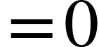

where C is the arbitrary constant which is the required general solution.

$$4$$

7.

**Solution:**



This is a separable equation.

Separating variable and we get,

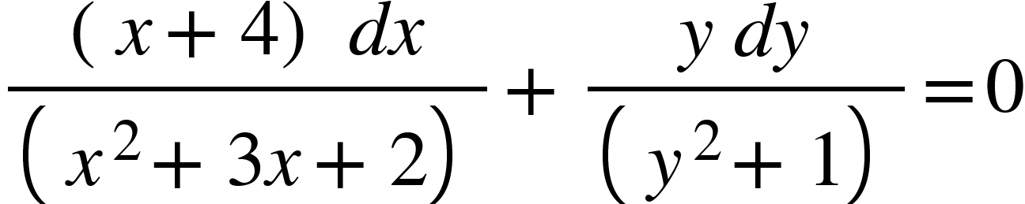

next we integrate,

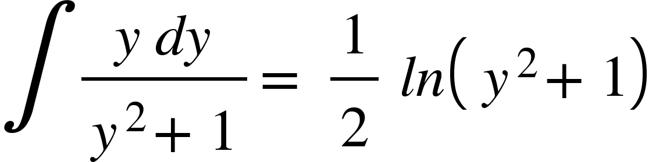

To integrate the dx term, we use the fractions. we get,

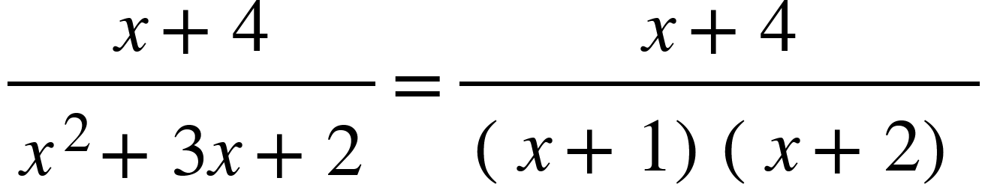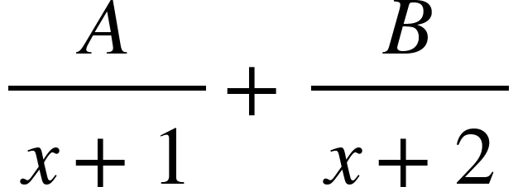



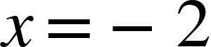

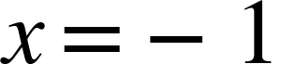

then gives A=3 and gives B=-2

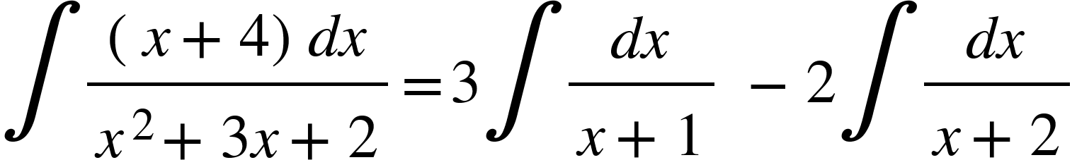



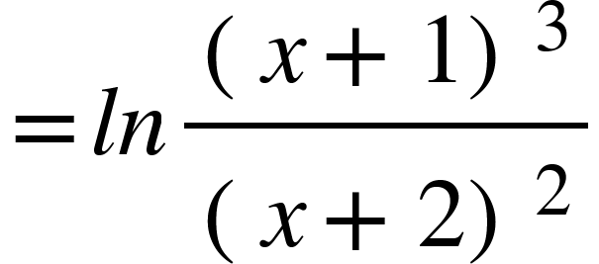

Now,

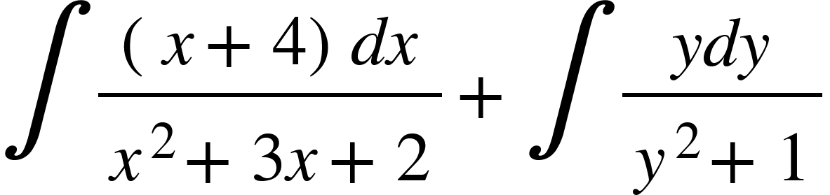

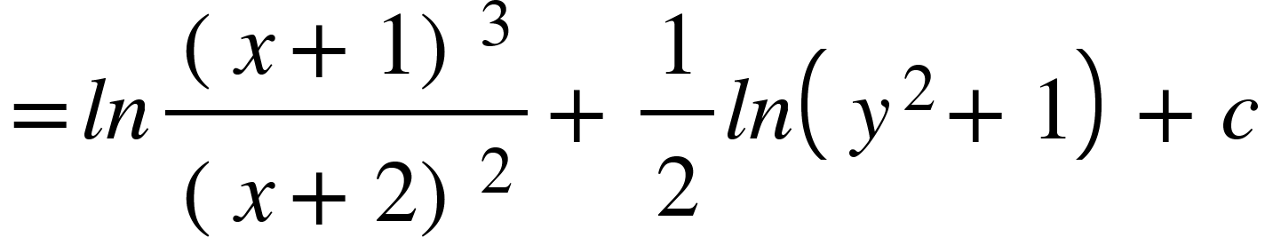

where C is the arbitrary constant which is the required general solution.

{"mathml":"<math xmlns=\"http://www.w3.org/1998/Math/MathML\" style=\"font-family:stix;font-size:16px;\"/>","origin":"MathType for Microsoft Add-in"}